Changing electronic use behavior in adolescents while studying: an interventional psychology experiment

Sirohi Kumar¹, Dawn Burgess¹

¹ Mount Desert Island High School, Bar Harbor, Maine

Student Authors

Sirohi Kumar, Mount Desert Island High School

SUMMARY
In an increasingly technological world, electronic distractions are ubiquitous and make focused studying difficult. Students surround themselves with technology while studying, despite a plethora of evidence that cell phones, television, and social media negatively impact academic performance. Thus, it seems that theoretical knowledge of the negative effects of electronic distraction on academic performance alone is insufficient to change students’ study habits. In this paper, we hypothesized that if high school students observed the change in their academic performance due to electronic distractions, they would be more likely to change their study habits. We conducted an interventional psychology experiment to test the verbal and visual memory of high school students with various distractions present. The students performed these tests while listening to instrumental music, lyrical music, television, or in silence. After the interventions, subjects were asked if they would change their study habits based on their interventions. All students were then surveyed two weeks after the interventions to determine if they had changed their study habits. A higher percentage of the control group changed their habits, but several treatment group subjects were found to have ruminated on their interventions and ultimately changed their habits despite initially not committing to. This prompts further exploration into this method of habit-breaking for students.

INTRODUCTION
Formalized, in-school education is one of the fundamental aspects of human development and serves as a benchmark for societal development. Access to education has been expanded by the advent of new technologies. Most American schools now provide students with devices to supplement their education (1). Students can take online lessons or receive in-school credit for online courses through various websites and organizations (2, 3). Many universities even offer entirely online degree programs. During the COVID-19 pandemic, many schools and colleges transitioned to entirely online classes; nearly 93% of American households with school-age children reported some form of distance learning (4).
However, the increased presence of technology has downsides. Many students find it difficult to focus when surrounded by so many distractions, and cognitive function is shown to suffer in the presence of cell phones and laptops (5, 6). Texting in class has been shown to decrease comprehension of material by 10–20% (7). Research has also shown that multitasking in class by using a laptop decreases comprehension of course material and degrades classroom performance (8).
Electronic distractions include more than just texting. Listening to music while working is an increasingly common practice among students, but the effect of music on focus, comprehension, and cognitive function is disputed. Some studies show that fast and loud music has a negative impact on reading comprehension (9-11). Other studies found that music with a fast tempo can improve the listener’s mood, awareness, and cognitive performance (12). The impact of music also depends on the listener. Studies state that if the listener enjoys music, it can increase their intellectual work performance (13). Individuals with a lower working memory capacity often find music to serve as a "seductive detail" and a distraction (14, 15). Additionally, introverts tend to have a lower reading comprehension than extroverts when listening to music (16). Still, other studies argue that music does not affect recall or short-term memory and that it provides neither assistance nor a handicap (17, 18).
Along with this conflicting research, many students themselves hold a variety of personal opinions about the effects of electronic distractions, not informed by research, but their own observations. We found that some students do not see music as a distraction but rather a tool that increases their focus and enhances their performance by drowning out extraneous noise in their environment. Some students feel that studying with music or social media present prevents them from getting bored while they work and stopping completely. Others use electronic distractions as an incentive for getting work done, rewarding themselves with a predetermined amount of screentime upon completing assignments. While the research is inconclusive, as discussed above, many students form their opinions independent of any scientific literature. Most interestingly, many students expressed sentiments along the lines of “I know [listening to music while studying is] bad. But I can’t stop”, implying that they feel electronic distractions have a negative impact on their cognitive function but are unable to break the study habit.
Habits are a behavioral pattern formed when the brain associates a cue or reward with a routine (19). Many students begin studying by opening a music or social media app, a cue that indicates the beginning of a learning routine. Electronic distractions incentivize studying, which may otherwise be an undesirable task, thus many students are unwilling to separate the two, despite the possible negative effects of electronic distractions. This experiment intended to explore these students’ inability and antipathy towards breaking certain study habits. We designed our study to assess whether students would change their study habits after directly witnessing how their habits influenced their learning.
We surveyed 64 high school students about their study habits, before and after one of two interventions to determine the best method for habit breaking. We hypothesized that observing the effects of electronic distractions would more effectively change student study habits than reading about them. We found that more subjects changed their study habits after witnessing the effects first-hand, although the difference was not statistically significant.

RESULTS
We attempted to determine the best method to change student study habits around electronic use. The study began with 69 participants, which decreased over the course of the study. Of those who completed the first stage of the study (the pre-intervention survey) 40 identified as female and 24 as male. There were 40 in grade 9, 11 in grade 10, 9 in grade 11, and 4 in grade 12. Changes in subject number and demographics will be discussed below.
First, we surveyed subjects on a variety of study-related areas, including the types of electronic distractions they commonly used while studying (Figure S1). We then randomly assigned subjects to a treatment or control group. We tested the verbal and visual memory skills of the treatment group in the presence of a variety of distractions: instrumental music, lyrical music, television, and the absence of distractions to simulate learning about changes in cognitive function through observation. Our control group read facts about the negative effects of electronics on cognition to simulate second-hand learning through literature. Immediately after their interventions, we asked both groups if they would change their study habits in any way (Figure S2). Lastly, we surveyed each subject two weeks after their interventions to determine if they had changed their study habits in any way (Figure S3).
We used the pre-intervention survey data to inform our treatment. We derived the conditions of the intervention from the most common distractions reported by subjects (Figure 1A). We eliminated cell phones as a possible distraction because we could not standardize a participant experience with “texting” or “social media”. We split music into lyrical and instrumental after seeing that subjects did not prefer one over the other. We also learned that subjects had an average of over two distractions present while studying, which we decided not to replicate to keep interventions under an hour (Figure 1B).
Once the treatment group subjects completed their interventions, we had a wealth of data about the impact of electronic distractions on verbal and visual memory. We wanted to determine if the order in which distractions were presented impacted subject scores. We randomized the order of distractions for each batch of subjects and then tested the significance of the difference between subject scores in the presence of each distraction (Figure 2). We found that verbal memory scores were not significantly impacted by the order of the distractions, for instrumental music (p = 0.560), lyrical music (p = 0.109), television (p = 0.989), or the absence of distractions (p = 0.485) (Figure 2A). Similarly, there was no impact of distractions on visual memory, for instrumental music (p = 0.541), lyrical music (p = 0.176), television (p = 0.649), or the absence of distractions (p = 0.117) (Figure 2B).
To determine if electronic distractions affected cognitive function, we compared subjects’ memory scores across distractions. We found that verbal memory scores were significantly higher in the presence of one distraction (p = 0.0005) (Figure 3A). By individually comparing each distraction, we found that verbal memory scores in silence were considerably higher than in the presence of other distractions. This suggests that distractions negatively affect verbal memory. However, we found no significant impact of distractions on visual memory scores (p = 0.556) (Figure 2B).
We also tested for any significant impact of subject gender or grade on memory scores by comparing the memory scores of female and male subjects in the presence of each distraction using t-tests. For verbal memory, there was no significant difference between the scores of female and male participants with no distractions present (t = 0.168, p = 0.860), while listening to lyrical music (t = 0.414, p = 0.671), instrumental music (t = 1.162, p = 0.109), or watching television (t = 0.253, p = 0.791) (Figure 3C). Male participants had significantly higher visual memory scores when listening to instrumental music (t = 3.262, p = 0.002) (Figure 3D). However, for all other distractions, there was no significant difference in visual memory scores between male and female participants: in the absence of distractions (t = 1.400, p = 0.152), when listening to lyrical music (t = 0.449, p = 0.641), or watching television (t = 1.301, p = 0.257) (Figure 3D).
We conducted similar testing using ANOVAs to see if subjects of any one grade had significantly different memory scores. For verbal memory, there was no significant difference between grades in the absence of distractions (F = 0.862, p = 0.470), when listening to lyrical music (F = -4.757, p = 1.000), instrumental music (F = 1.184, p = 0.330), or watching television (F = 1.933, p = 0.143) (Figure 3E). Similarly, for visual memory, there were no significant differences in subject scores between grades in the absence of distractions (F = 1.142, p = 0.346), when listening to lyrical music (F = 0.805, p = 0.500), instrumental music (F = 1.311, p = 0.286), and watching television (F = 2.320, p = 0.092) (Figure 3F).
Next, we analyzed the results of the follow-up survey that each participant completed two weeks after their intervention. We compared the reported changes in habit to the commitments subjects made directly after interventions to determine the more effective method to get students to change their habits. Initially, 60.00% of the control group (n = 12) committed to changing their habits (Figure 4A). After two weeks, those 12 subjects reported having changed their study habits (Figure 4B). Due to a decrease in participation over that two-week interval, this means 63.16% of the control group followed through on their commitments. Of the treatment group, 41.03% (n = 16) committed to changing their habits directly after their interventions (Figure 4A). Two weeks later, 55.56% of the treatment group (n = 20) reported having changed their study habits, meaning that four subjects in the treatment group had thought about their experience with the interventions and decided to change their study habits (Figure 4B). Thus, both interventions had an impact on subjects; a higher percentage of subjects in the control group followed through on their commitments, but the treatment group subjects showed evidence they had reconsidered their stance on their study habits.
To determine significance, we compared the proportion of subjects in the treatment and control group who followed through on their commitments using a z-test. We found no significant difference between the long-term effects of the different interventions between the treatment and control groups (z = 1.736, p = 0.4956) (Figure 4C). Despite the lack of statistical significance, the fact that several treatment group subjects changed their minds during the two-week period is an indication they may have ruminated over the intervention, which prompts further exploration with a larger sample size.
Throughout the study, the number of subjects decreased as participants failed to come to interventions and fill out the follow-up survey. By the last stage of the study, we observed the gender and grade makeup of the remaining participants was very different from the beginning of the study (Figure 5). The general applicability of this study relied on having a random sample of the high school population, so, using ANOVAs, we tested if the changes in subject demographics over the course of the study were significant. We based our expected number of subjects in each demographic group (female subjects, 10th graders, etc.) on the proportion of total subjects in each demographic that agreed to participate.
There was no statistical significance to the change in grade demographics from agreeing to participate and signing the consent form (p = 0.199), to completing the pre-intervention survey (p = 0.128), to completing their interventions (p = 0.142), to completing the post-intervention survey (p = 0.087) (Table 1). However, at the last stage of the experiment, the p-value approaches significance, which suggests that if the grade demographics continued shifting in the same way (11th and 12th grade participants decreasing), the number of subjects in each grade may have become significantly different. Similar to subject grades, the change in female and male participants remain not significant from agreeing to participate, to signing the consent form (p = 0.977) to completing the pre-intervention survey (p = 0.628), to completing their intervention (p = 0.766), to completing the follow-up survey (p = 0.382) (Table 2).

DISCUSSION
We found that when given the chance to read about the impact electronic distractions have on cognition, a large proportion of students will choose to change their habits. However, when presented with the impact of electronic distractions, the proportion of students who demonstrate habit change increases from the initial commitment time to the two week long-term benchmark. We feel conducting this study again with a larger sample size will provide further insight. We also recommend modifying the follow-up survey to include questions about how, specifically, participants changed their habits to gain more insight on the efficacy of the interventions.
Our results show electronic distractions had a statistically significant effect on verbal memory. However, distractions had no effect on visual memory, which provides conflicting evidence about the impact of electronic distractions, particularly music, on memory. Additionally, neither the grade nor gender of the subject had a significant impact on their verbal and visual memory, with one exception: male participants had significantly higher visual memory scores when listening to instrumental music. Further experiments are necessary to determine the exact cause of this difference.
While the change in grade demographics of subjects was not significant, it approached significance. The decreasing number of 11th and 12th grade participants throughout the study is also worth noting. The authors’ personal relationships with the subjects may have caused this change. The study required nearly a month of participation, and a personal relationship with the authors may have incentivized subjects to complete the study. To address this potential bias, future experiments should use a non-student party as the subjects’ proctor and contact.
There are also a few differences between the control and treatment groups’ interventions, chief among them the contents of the control group’s questionnaire, which consisted solely of facts about the negative effects of electronic distractions (Figure S2). However, we did not take measures to ensure the treatment group only saw distractions as a negative influence on their scores; there were treatment group subjects who had an improved memory performance in the presence of distractions compared to in silence (Table 3). The positive impact of distractions for the treatment group makes the interventions unbalanced, which could impact the study’s short- and long-term results. For instance, 13 subjects in the treatment group saw lyrical music improve their memory performance (Table 3). Contrast this to the control group, who were told that listening to lyrical music negatively impacts cognitive skills (Figure S2). Subjects could have then made opposite initial commitments because of what they learned, not how they learned it. To address this difference, we would modify the control group’s treatment to include positive and negative facts about the effects of various electronic distractions to simulate an experience more like that of the treatment group.
Additionally, because simulating a standardized presence of social media or text message notifications for all subjects was not feasible, we eliminated cell phones as a distraction for the treatment group, despite them being the most common distraction reported by participants in the pre-intervention survey. However, the effect of cell phones was still included in the control group’s intervention (Figure S2). Again, learning about different distractions may have impacted why the subjects decided whether to change their habits.
One potential cause for error was the decrease in participation throughout the study. While we found that the changes in gender and grade demographics were not significant, they approached significance, and if they occurred again in a future version of this study, they could have decreased the general applicability of the findings (Table 1). To address this, we recommend conducting this study again with a larger sample size and that results be corrected for shifts in subject demographics to reduce gender or grade bias.
We are interested in further exploring the relationship between treatment group scores and their commitment to habit change. We would like to quantify the “tipping point” in memory performance at which subjects in the treatment group decide to change their habits. Subjects’ scores are numeric, so we could feasibly show the relationship between subjects’ scores and habit changes.
Further avenues for study include the longer-term effects of the intervention and how the age of the subject impacts their habits. The study only surveyed changes in study habits after two weeks, but subjects may revert to old habits over time. By surveying several points post-intervention, we could more accurately determine the efficacy of each intervention. Conducting the same interventions on subjects in different age groups is also relevant, as subjects who have had the habit for varying times may react differently to the treatment. Understanding the difference in effect for subjects with a, more or less, entrenched habit could provide key information on the optimal time to break this kind of study habit.
We could also explore the wide variety of reported electronic distractions. As mentioned earlier, we could not standardize the presence of a cell phone for each subject, so we eliminated it as a distraction. However, subjects reported using technology in a variety of ways while studying, including different apps and types of music. These nuances could be interesting to explore. For instance, are subjects more likely to change their habits if the music they listen to is unfamiliar? Of a certain genre? Is it harder to stop watching YouTube while studying than scrolling on Instagram? Which has a bigger impact on memory and cognitive function? These are all questions we are interested in exploring.
Due to design constraints, the treatment group’s intervention presented only one distraction at a time. However, the pre-intervention survey showed that most subjects studied with an average of two distractions present (Figure 1B). This inconsistency means subjects’ real world studying conditions are more distracting than in the experimental setting. Adjusting the treatment to explore what combinations of distractions have the most impact on subjects could be illuminating.

MATERIALS AND METHODS
Recruitment of Participants
We emailed every student at Mount Desert Island High School, asking for volunteers to participate in this experiment. The email provided details about the purpose of the study and the time commitment required. We instructed interested participants to reply to the email, so participation was based on availability. At this point, we made sure all proceeding participants (and their parents if they were underage) signed a Human Informed Consent Form, as mandated by the Maine State Science Fair’s Ethics Guidelines. Thus, we began our experiment with 69 subjects, who we divided randomly into treatment (39 subjects) and control (30 subjects) groups. We then asked all subjects to fill out a pre-intervention survey that provided background information on their study habits (Figure S1).

Experimental Design
The control group’s intervention was a questionnaire that presented them with several facts about the impacts of electronics on their cognitive function (Figure S2). Every fact came with the question, “Did you already know this?” to ensure subjects read them. The answer did not change how their responses were recorded. At the end of the questions, the subjects were asked, “After reading these facts, do you plan to change how you study in any way?”.
The treatment group’s intervention consisted of two online tests from The Human Benchmark for verbal and visual memory. These tests were repeatedly completed under a variety of different conditions (20). The verbal memory test presented each subject with a word and asked them if they had seen it in this round. If the player responded accurately (either yes, they had or no they had not), the game would present them with another word. This continued until they had responded incorrectly three times, at which point they would be scored. In the visual memory test, a square of tiles was presented to the player, increasing in width and height every three levels. Each level, a random selection of the tiles would flash white. The user then had to recreate the pattern by clicking on tiles. If they made three mistakes, they lost a life. When the user lost three lives, the game ended, and they were scored.
The conditions of the treatment group’s interventions were as follows: silence, instrumental music (a Betawaves simulation from Spotify), lyrical music (a mashup of 2000s pop hits), and television (episode one of American TV show The Office). The order of distractions was randomized to avoid an impact on scores.
Treatment group subjects scheduled their interventions for an hour either before school, after school, or during the lunch block, based on availability. They used their school laptops to complete the tests. The interventions were conducted in an empty classroom. Subjects had 10 minutes per condition to complete both tests and record their scores on paper. After all tests, the proctor asked each subject, “After looking at your results, do you plan to change how you study in any way?”, and had them record their responses on their score sheets to avoid subjects influencing each other. Subjects often discussed their scores and decisions with each other; the proctor did not prompt or prevent discussion. Exactly two weeks after they completed their interventions, we reached out to each participant, and they completed a final survey asking if they had changed their habits in any way since their interventions (Figure S3).

Statistical Analysis
We created and distributed all surveys with Google Forms. Results were linked to a Google spreadsheet. Scores and commitments were transcribed from paper score sheets to the Google spreadsheet by hand. Graphs and tables were created in Google Sheets and RStudio (using the ggplot2 package). T-tests, Z-tests, ANOVAs, and chi-square tests were completed in Google Sheets (ANOVA required the Google Sheets add-on XLMiner Analysis Toolpak).

ACKNOWLEDGEMENTS
We would like to thank all the student participants for their time, patience, and energy. We would like to thank Megan McOsker for her guidance as MDI High School’s Science Fair Coordinator and Linda Richardson for her help with subject outreach. Thank you to Michelle Merica her guidance with manuscript submission. Lastly, we would like to thank Dr. Linda Fuller at the College of the Atlantic for her assistance with intervention design.

REFERENCES

- Evans, Julie. “Project Tomorrow | Speak Up.” Digital Learning during the Pandemic: Emerging Evidence of an Education Transformation, 2020, tomorrow.org/speakup/2020CB-Digital-Learning-during-the-Pandemic.html.
- Virtual High School. “About Us.” About Us, 2021, www.vhslearning.org/about-us.
- Khan Academy. “About | Khan Academy.” Our Mission Is to Provide a Free, World-Class Education for Anyone, Anywhere., 2021, www.khanacademy.org/_render.
- McElrath, Kevin. “Nearly 93% of Households With School-Age Children Report Some Form of Distance Learning During COVID-19.” The United States Census Bureau, 26 Aug. 2020, www.census.gov/library/stories/2020/08/schooling-during-the-covid-19-pandemic.html.
- Shelton, Jill T., et al. “The Distracting Effects of a Ringing Cell Phone: An Investigation of the Laboratory and the Classroom Setting.” Journal of Environmental Psychology, vol. 29, no. 4, Dec. 2009, pp. 513–21. https://doi.org/10.1016/j.jenvp.2009.03.001
- Trafton, J. Gregory, et al. “Preparing to Resume an Interrupted Task: Effects of Prospective Goal Encoding and Retrospective Rehearsal.” International Journal of Human-Computer Studies, vol. 58, no. 5, May 2003, pp. 583–603. https://doi.org/10.1016/S1071-5819(03)00023-5
- Lawson, Dakota, et al. “The Costs of Texting in the Classroom.” College Teaching, vol. 63, no. 3, July 2015, pp. 119–24, https://doi.org/10.1080/87567555.2015.1019826
- Fried, Carrie B. “In-Class Laptop Use and Its Effects on Student Learning.” Computers & Education, vol. 50, no. 3, Apr. 2008, pp. 906–14. https://doi.org/10.1016/j.compedu.2006.09.006
- Goltz, Franziska, et al. “Do You Listen to Music While Studying? A Portrait of How People Use Music to Optimize Their Cognitive Performance.” Acta Psychologica, vol. 220, Oct. 2021, p. 103417. https://doi.org/10.1016/j.actpsy.2021.103417
- Perham, Nick, et al. “Does Listening to Preferred Music Improve Reading Comprehension Performance?” Applied Cognitive Psychology, vol. 28, Mar. 2014. https://doi.org/10.1002/acp.2994
- Thompson, William, et al. “Fast and Loud Background Music Disrupts Reading Comprehension.” Psychology of Music, vol. 40, Nov. 2012, pp. 700–08. https://doi.org/10.1177/0305735611400173
- Husain, Gabriela, et al. “Effects of Musical Tempo and Mode on Arousal, Mood, and Spatial Abilities.” Music Perception: An Interdisciplinary Journal, vol. 20, no. 2, 2002, pp. 151–71. https://doi.org/10.1525/mp.2002.20.2.151
- Hiwa, Satoru, et al. “Functional Near-Infrared Spectroscopy Study of the Neural Correlates between Auditory Environments and Intellectual Work Performance.” Brain and Behavior, vol. 8, no. 10, 2018, p. e01104. https://doi.org/10.1002/brb3.1104
- Rey, Günter Daniel. “A Review of Research and a Meta-Analysis of the Seductive Detail Effect.” Educational Research Review, vol. 7, Dec. 2012, pp. 216–37. https://doi.org/10.1016/j.edurev.2012.05.003
- Sanchez, Christopher A., et al. “An Examination of the Seductive Details Effect in Terms of Working Memory Capacity.” Memory & Cognition, vol. 34, no. 2, Mar. 2006, pp. 344–55. https://doi.org/10.3758/BF03193412
- Furnham, Adrian, et al. “Music Is as Distracting as Noise: The Differential Distraction of Background Music and Noise on the Cognitive Test Performance of Introverts and Extraverts.” Ergonomics, vol. 45, no. 3, Feb. 2002, pp. 203–17. https://doi.org/10.1080/00140130210121932
- Lehmann, Janina A. M., et al. “Can Music Foster Learning – Effects of Different Text Modalities on Learning and Information Retrieval.” Frontiers in Psychology, vol. 8, Jan. 2018, p. 2305. https://doi.org/10.3389/fpsyg.2017.02305
- Rauscher, Frances H., et al. “Music and Spatial Task Performance.” Nature, vol. 365, no. 6447, 6447, Oct. 1993, pp. 611–611. https://doi.org/10.1038/365611a0
- Gardner, Benjamin, et al. “Making Health Habitual: The Psychology of ‘Habit-Formation’ and General Practice.” The British Journal of General Practice, vol. 62, no. 605, Dec. 2012, pp. 664–66. https://doi.org/10.3399/bjgp12X659466
- Human Benchmark. Human Benchmark. 2023, humanbenchmark.com/.

FIGURES
Figure 1. Results of the pre-intervention survey. All subjects completed a pre-intervention survey on their study habits before being randomly divided into treatment and control groups. (A) The most common electronic distractions subjects reported using while studying. (B) The number of distractions subjects usually had present while studying.
Figure 2. Impact of distraction order on scores. The verbal and visual memory scores of treatment group subjects under each electronic distraction condition based on the order in which distractions were presented. (A) The effect of the order of distractions on verbal memory scores. (B) The effect of the order of distractions on visual memory scores. All p-values are non-significant.
Figure 3. Analysis of the treatment group’s memory scores. (A) The effect of distractions on visual memory scores across all subjects. (B) The effect of distractions on verbal memory scores across all subjects. (C) Distribution of verbal memory scores in the presence of various distractions between genders. (D) Distribution of visual memory scores in the presence of various distractions between genders. (E) Comparison of all verbal memory scores across subject grades. (F) Comparison of all visual memory scores across subject grades.
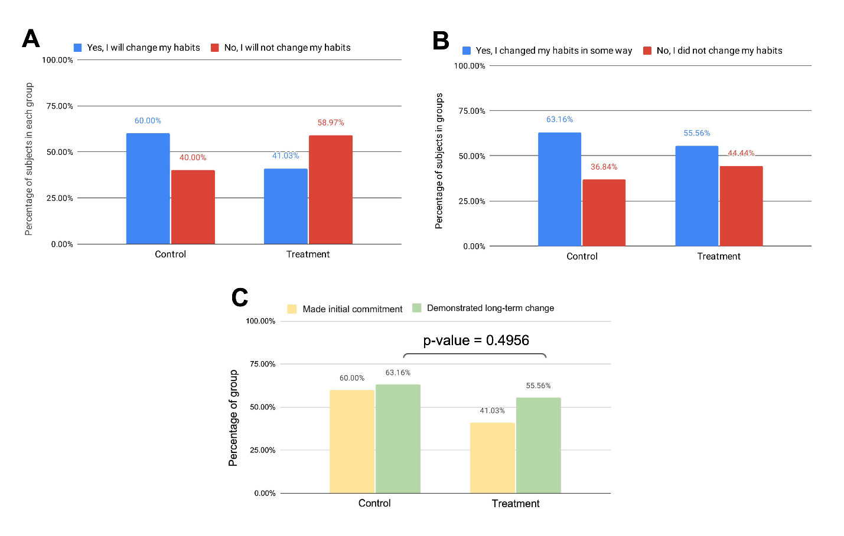
Figure 4. Analysis of subject post-intervention surveys. Percentage of subjects in each group who (A) committed to changing their habits directly after their intervention, (B) who reported having changed their habits two weeks after interventions, and (C) who initially committed to habit change and who carried out some habit change over the next two weeks. The difference in long-term commitment is not significant.
Figure 5. Meta-analysis of subject participation. (A) The number of subjects in each grade throughout the stages of the experiment. (B) The number of male and female subjects throughout stages of the experiment.

Table 1. Significance of change in subject participation by grade throughout the study. Chi-square values from changes in subject grades throughout each stage of the study.
 | Asked to participate | Agreed to participate |  | Signed consent form |  | Completed pre-intervention survey |  | Completed intervention |  | Completed post-intervention survey
 | Total subjects | Count | Proportion | Observed | Expected | Observed | Expected | Observed | Expected | Observed | Expected
Grade 9 | 128 | 50 | 0.21 | 41 | 14.60 | 40 | 13.54 | 35 | 12.27 | 33 | 11.00
Grade 10 | 144 | 22 | 0.19 | 14 | 13.27 | 11 | 12.31 | 13 | 11.15 | 11 | 10.00
Grade 11 | 125 | 20 | 0.12 | 10 | 7.96 | 9 | 7.38 | 7 | 6.69 | 5 | 6.00
Grade 12 | 140 | 12 | 0.48 | 4 | 33.17 | 4 | 30.77 | 3 | 27.88 | 3 | 25.00
Total | 537 | 104 | 1.00 | 69 |  | 64 |  | 58 |  | 52
p-value | N/A | N/A |  | 0.19949 |  | 0.12796 |  | 0.14207 |  | 0.08733

Table 2. Significance of change in subject participation by gender throughout the study. Chi-square values from changes in subject genders throughout each stage of the study.
 | Asked to participate | Agreed to participate |  | Signed consent form |  | Completed pre-intervention survey |  | Completed intervention |  | Completed post-intervention survey
 | Total subjects | Count | Proportion | Observed | Expected | Observed | Expected | Observed | Expected | Observed | Expected
Male | 270 | 36 | 0.35 | 24 | 23.88 | 24 | 22.15 | 19 | 20.08 | 15 | 18.00
Female | 267 | 68 | 0.65 | 45 | 45.12 | 40 | 41.85 | 39 | 37.92 | 37 | 34.00
Total | 537 | 104 | 1.00 | 69 |  | 64 |  | 58 |  | 52
p-value | N/A | N/A |  | 0.97671 |  | 0.62763 |  | 0.76629 |  | 0.38186

Table 3. Comparison of benefit and harm experiences of treatment subjects during interventions. Number of subjects in the treatment group who saw a benefit or harm to their verbal and visual memory scores under other conditions, as compared to silence.
 | Instrumental music |  | Lyrical music |  | Television
 | Benefit | Harm | Benefit | Harm | Benefit | Harm
Verbal Memory | 17 | 52 | 13 | 56 | 11 | 58
Visual Memory | 23 | 46 | 21 | 48 | 24 | 45

APPENDIX

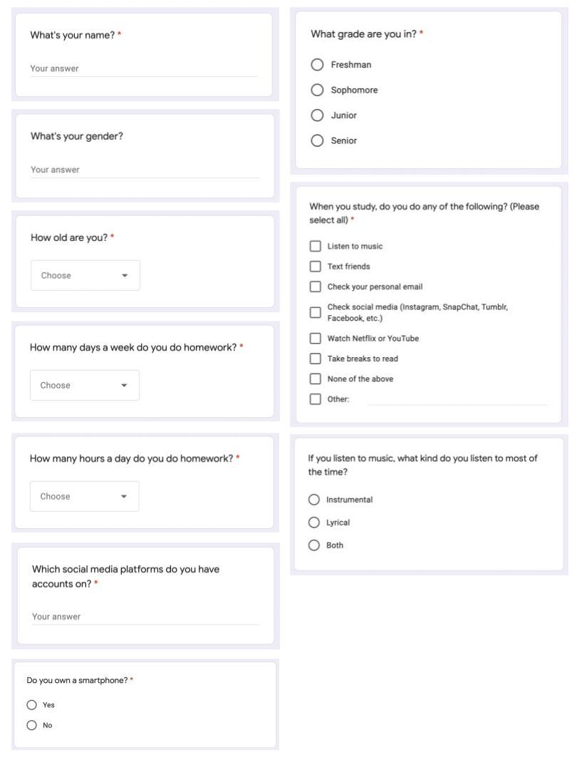
Figure S1. Pre-intervention survey completed by all subjects.
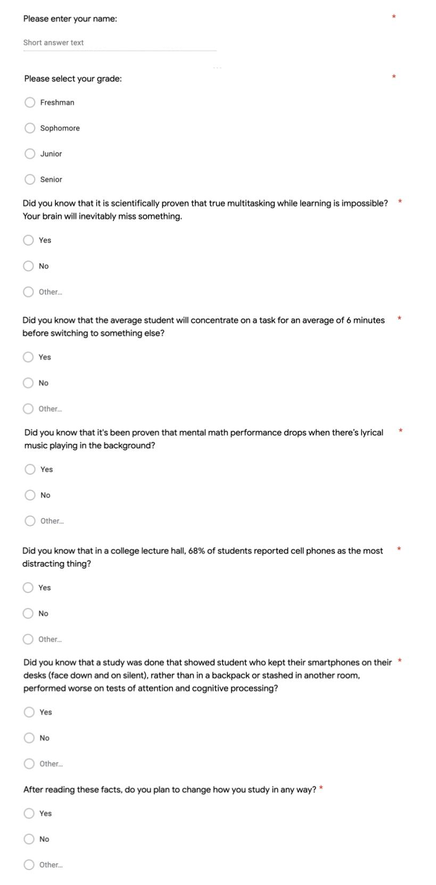
Figure S2. Questionnaire completed by all subjects in the control group.

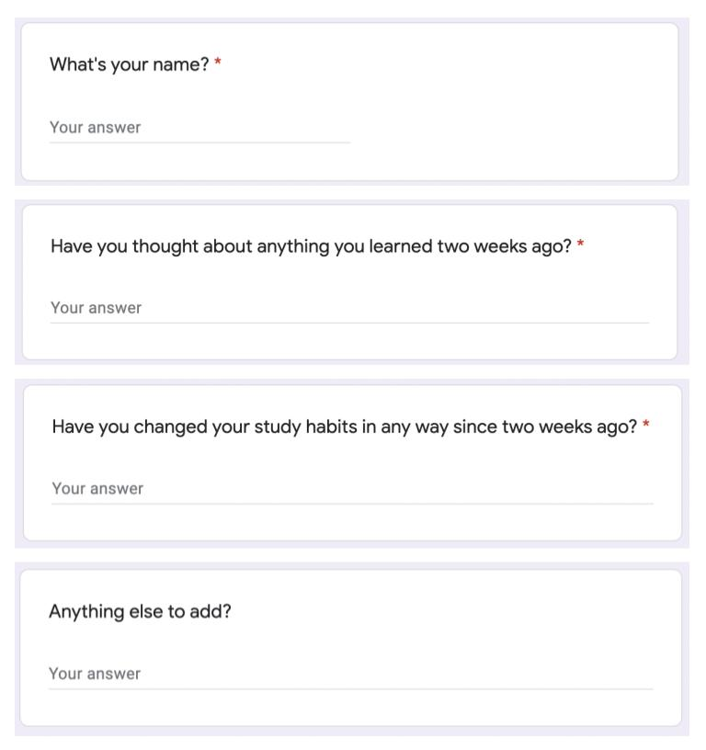
Figure S3. Post-intervention follow-up survey completed by all subjects.

